S.NO | NAME OF THE TEACHER |  | DESIGNATION |  | QUALIFICATION WHETHER HAVING MBA I CLASS | WHETHER HAVING PH.D DEGREE IN MANAGEMENT | DATE OF BIRTH | TOTAL NO OF YEARS OF EXPERIENCE | NATURE OF APPOINTMENT |  | PHOTO | DETAILS OF AADHAAR CARD,  PAN CARD,  BANK ACCOUNT NO
 |  |  |  |  |  |  |  |  | THROUGH O.U SELECTION COMMITTEE | MANAG  EMENT | PHOTO | DETAILS OF AADHAAR CARD,  PAN CARD,  BANK ACCOUNT NO
1 | Dr.(Mrs)ZEHRA  KHAN. |  | Principal |  | MBA, Ph.D. | Yes | ’08-07-1984 | 10 |  |  |  | 270653772539,  DZRPK2226K,  043701000084786,  IOB BANK
2 | Dr. M.MANJULA |  | Associate professor |  | MBA, Ph.D. | Yes | ’14-01-1973 | 13 |  |  | 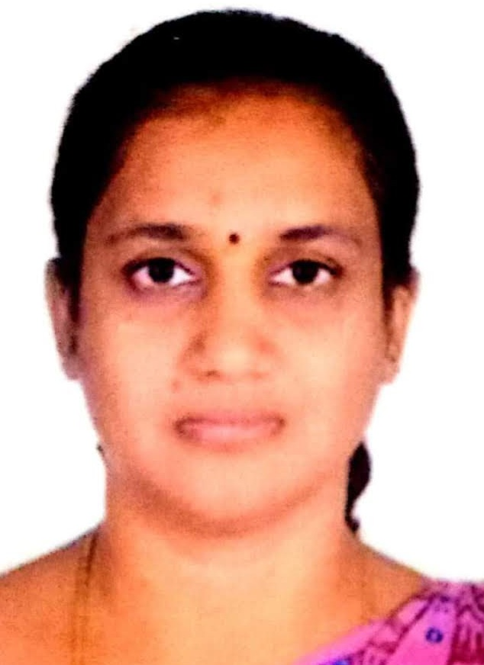 | 478734239583  AMCPM4193Q  7228641979  INDIAN BANK
3 | Dr. KHUDSIYA ZEESHAN |  | Associate professor |  | MBA, Ph.D. | Yes | ’21-091979 | 10 |  |  | 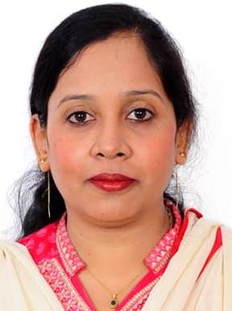 | 235328253485 AAIPZ7690M 004801555477  ICIC0000048  ICICI BANK
4 | Mr. S.VIDYA SAGAR |  | Associate professor |  | MBA , M.Phil | NO | 04-07-1974 | 13 |  |  | 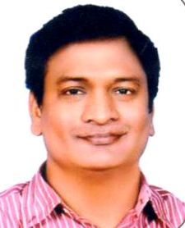 | 818869195958,  BDXPS2336G ,  705381371 ,  INDIAN BANK
5 | Mr. S.CHANDRA SHEKHAR |  | Assistant. Professors |  | M.Tech, MBA. | NO | 02-08-1969 | 10 |  |  | 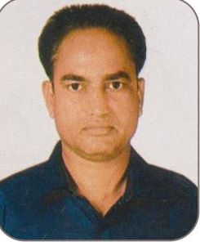 | 351948988047,  BBXPS2400R ,  418419042 ,  INDIAN BANK.
6 | Mr.MD YOUNUS |  | Assistant. Professors |  | MBA. | No | ’14-11-1983 | 06 |  |  | 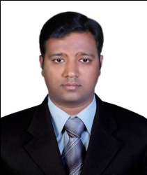 | 699331748845,  AOIPY3693D ,  1849101026530,  CANARA BANK.
7 | Mr.MD GHOUSE |  | Assistant. Professors |  | MCA,MBA. | No | ’20-09-1979 | 10 |  |  | 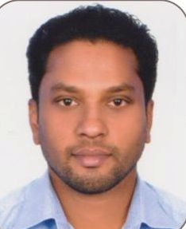 | 324510474633,  BMIPG9092D,  914010019773556,  Axis bank.
8 | Mr.MD RAHMAN SHAREEF | Assistant. Professors |  | MBA. |  | No | ’01-08-1948 | 10 |  |  |  | 251906800846,  ABKPM4233L,  031010100001246,  Andhra bank.
9 | Mr.MD. AFROZE | Assistant. Professors |  | MBA. |  | No | 20-04-1988 | 04 |  |  | 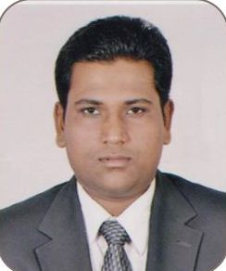 | 485624558387,  BVBPM6888D,  2006184,  DRB BANK.
10 | Mr.ABU BAKAR ABDUL AZIZ JABRI | Assistant. Professors |  | MBA. |  | No | ’15-10-1987 | 04 |  |  |  | 485354145842,  ASJPJ7771N ,  62176641748 ,  SBI BANK.
11 | Mr.MD AKRAM ALI | Assistant. Professors |  | MBA. |  | No | ’26-10-1987 | 04 |  |  | 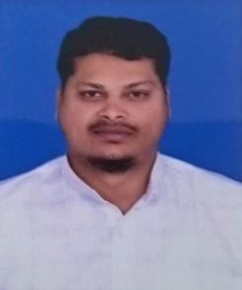 | 741628137933,  AXKPA2913P,  30702340844,  SBI BANK.
12 | Mr.MD MUKTHIYAR AHMED | Assistant. Professors |  | MBA. |  | No | ’04-07-1971 | 08 |  |  | 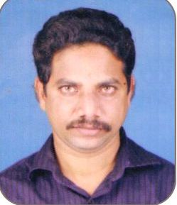 | 760961190969,  KWPA6352R,  6211695598 ,  INDIAN BANK.
13 | S.M.NAJAFULLAH | Assistant. Professors |  | MBA. |  | No | ’16-01-1966 | 08 |  |  |  | 848335956164,  AVDPS6969C,  10009565707,  SBI BANK.
14 | Mr. SYED MUBASHIR AHMED | Assistant. Professors |  | MBA. |  | No | ’10-04-1993 | 03 |  |  |  | 504699041042, HCDPS6060N,  6785240537,  INDIAN BANK.

